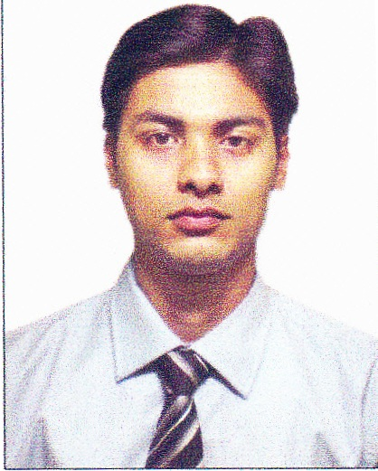

**Contact:** 1074, P.S Road, Dum Dum

Kolkata- 700030, WB, India

Mob: **+91(0) 9903448003**

Email: arindam.sinha2389@live.com

**ARINDAM SINHA**

DOB: 23rd February 1989

**Profile:**

A qualified Graduate and a fulltime MBA seeking a responsible job with an opportunity for professional challenges in the area of Marketing and Sales.

**Key Skills and Areas of Expertise:**

* Achieving monthly and yearly targets. Aligning resources to achieve the same**.**
* Working with creative teams, operations and field staff. Ensuring optimum utilization of company resources.
* Team player with strong analytical and Leadership Skills.
* Optimizing the company and client resources.

**Proficiencies and Specialties:**

* Brand Management
* Brand Architecture
* Customer Insight
* Consumer Behavior
* Market Research
* Market Segmentation
* Global Marketing
* Marketing Strategy
* Product Marketing
* Advertising
* Networking
* Team Leadership

**Training & Workshops Attended:**

**Summer Internship Project Details**

Company : Tractors India Limited (TIL)

Project Title : “Lead Generation In BCP and GCI Segments – Gap Analysis And Evolving New Techniques”

Period : June – August, 2012

Learning from the Project : The project report is all about the generating leads, creating clients

and about technical and the commercial aspect of the company

through market survey, market analysis, market research, promotional

activities.

**Work Experiences:**

**Company Details 1:**

Company Name : JAT GLOBAL PVT LTD

Period : August, 2016 to Till Date

Position : Sales Officer

**Job Responsibility:**

* Meet Sales Targets
* Both Secondary & OEM Sales
* Demand Generation
* Obtaining order & leads from the Sub dealer Channel through regular visits as per beat plan
* Lead Generation from the list of influencers assigned & Market scouting Conversion of leads into sales in coordination with Main Dealer & Sub dealers Ensuring Timely Delivery to the OEMs/ End Customers
* Execute the BTL activities ( Shop Meet/ Influencer Meet or any in shop activities)

**Company Details 2:**

Company Name : Jubilant Agri & Consumer Products Ltd. (Jivanjor)

Period : May, 2015 to August, 2016

Position : Area Development Executives (Marketing)

**Job Responsibility:**

* Marketing Strategies & Campaigns
* Corporate Communications
* Creative Team Leadership
* Product Positioning & Branding
* New Product Launch
* Analyzed market trends to address business opportunities and issues, and to set the brands’ annual objectives, strategies, positioning, tactics and measures.
* Conducted market surveys to define target audience, constructed forecasts and budgets.
* Conducting frequent surveys among the customers regarding the requirements of products at present and estimating the requirements in the future.
* Analyzed current market trend and competitor information.
* Prepared the pricing strategy of the product.
* Display for eye catching- Selected special products to be displayed at promotional events and exhibitions.

**Company Details 3:**

Company Name : Serco India Ltd. (American Express India Ltd.)

Period : October, 2013 to May, 2015

Position : Business Development Executives

**Job Responsibility:**

* Prospecting for new customers through existing leads and cold calling and maximizing lead generation.
* Timely execution of all sales activities - leads, campaigns, referrals & any self generated leads.
* Set appointments, listen to customer needs and sell most appropriate product.
* Researches and understands prospects before making the call.
* Ensures all applications are fully and accurately completed and submitted properly.
* Be the interface between Amex and the customer to resolve any application processing issues.
* Drive the on-boarding of new customers and initiates spend enablement activities.
* Attend relevant industry and partner conferences, tradeshows and networking events.
* Engaging with premium customers to build relationships, and delivering a positive customer experience while acquiring new customers.

**Co curricular Activities:**

* Organize Blood Donation Camp in college.
* Participated in Global Entrepreneurship Summit, 2012 in IIT-KGP.

**Education:**

|  |  |  |  |  |
| --- | --- | --- | --- | --- |
| **YEAR** | **ACADEMIC LEVEL** | **BOARD** | **MAJOR SUBJECT** | **RESULT** |
| 2011-2013 | MBA | W.B.U.T  HERITAGE BUSINESS SCHOOL | MAJOR: MARKETING  MINOR: FINANCE | DGPA- 6.63 |
| 2009-2011 | POST GRADUATION (M.A) | GURU GHASIDAS CENTRAL UNIVERSITY, BILASPUR (C.G) | GEOGRAPHY | 61% |
| 2006-2009 | GRADUATION (B.SC) | CALCUTTA UNIVERSITY | GEOGRAPHY (HONS) | 46.5 % |
| 2004-2006 | HIGHER SECONDARY | W.B.C.H.S.E | GEOGRAPHY, ECONOMICS, SANSKRIT | 64.1 % |
| 2004 | MADHYAMIK | W.B.B.S.E | All | 70 % |

**Other Details:**

LANGUAGE PROFICIENCY : English, Bengali and Hindi

IT SKILLS : Windows XP, windows 7, Microsoft Office (Word, Excel, PowerPoint),

Microsoft outlook

INTERESTS AND ACTIVITIES : Photography, Cricket & computer games, interacting

with people, organizing various cultural, social, sports related programmes & activities in school, college.

Declaration:

I hereby declare that all the information mentioned herein is true to the best of my knowledge.

Date : ………………………………

Place : Kolkata ARINDAM SINHA